**COVID-19 2021 YEARLY REPORT**

**INTRODUCTION**

The year 2021 was marked by significant challenges in the fight against the COVID-19 pandemic. This report provides a detailed analysis of the yearly impact, focusing on total cases, recoveries, death rates, and state-wise distribution. The insights gathered from the data help highlight key trends and areas requiring further attention. Understanding these trends is crucial for developing more effective healthcare policies and response strategies.

**OVERVIEW OF COVID-19 IMPACT**

* **Total Confirmed Cases:** 237,561
* **Total Recoveries:** 212,550
* **Total Deaths Recorded:** 30,022
* **Death Rate:** 1.27%

The data suggests a high recovery rate of approximately **89.5%**, indicating that most infected individuals successfully overcame the virus with appropriate medical interventions. However, the recorded **30,022 deaths** emphasize the need for continued healthcare support and disease prevention measures. The **death rate of 1.27%** is relatively low compared to global averages, reflecting the effectiveness of Nigeria’s COVID-19 response.

**DEATH RATE ANALYSIS**

* The overall death rate of **1.27%** suggests that while fatalities occurred, a significant majority of cases were successfully treated.
* **Kogi recorded an exceptionally high death rate of 40%**, raising concerns about possible underreporting of cases or challenges in healthcare response and infrastructure.
* Other states with moderate death rates include:
  + **Cross River – 3.59%**
  + **Edo – 3.85%**
  + **Kebbi – 3.40%**
  + **Sokoto – 3.46%**

The high mortality rate in Kogi suggests that either the state had inadequate testing and case reporting, or it struggled with effective COVID-19 management. The relatively lower death rates in other states indicate better healthcare responses and interventions. Further research into the discrepancies in Kogi’s data is essential for accurate nationwide reporting.

**MONTHLY CASE TRENDS**

* **January to April:** A sharp decline in cases was observed, indicating that early interventions, lockdown measures, and vaccinations played a role in controlling the spread of the virus.
* **May to November:** A period of relative stability in case numbers suggests that the virus transmission was being managed effectively, possibly due to widespread immunization efforts and public health awareness campaigns.
* **December:** A notable surge in COVID-19 cases occurred, likely attributed to increased travel, holiday gatherings, and relaxed restrictions. This spike underscores the need for continued public health vigilance, particularly during festive periods when compliance with preventive measures tends to decrease.

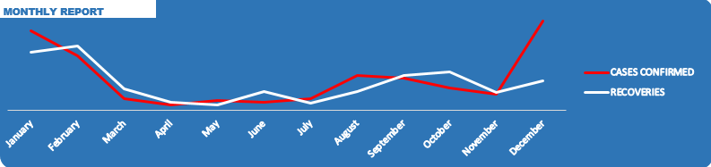

The seasonal variations in infection rates reinforce the importance of **adaptive response strategies**, such as reinforcing restrictions before high-risk periods and promoting booster vaccinations before anticipated surges.

**STATE-WISE ANALYSIS**

**Most Affected States**

* **Lagos (92,128 cases)** remains the epicenter of the pandemic due to its **high population density, extensive economic activities, and significant domestic and international travel connections**.

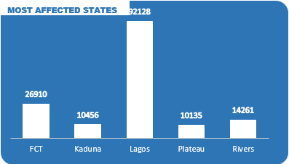

* + Lagos, as Nigeria’s economic hub, has **a high influx of travelers**, leading to a faster spread of the virus.
  + The city’s dense urban environment, where people live in close proximity, significantly increases transmission rates.
  + Despite high case numbers, Lagos also recorded a substantial number of recoveries, indicating **a well-equipped healthcare system** with better access to treatment compared to other states.
  + The government’s response, including lockdowns, curfews, and vaccination drives, helped manage the spread but was not enough to prevent it from becoming the most affected state.
  + Lagos also saw **strong collaboration between the government, private sector, and healthcare institutions**, which enabled a more coordinated response. However, challenges such as vaccine hesitancy, misinformation, and socio-economic constraints limited the full effectiveness of control measures.
  + The large informal sector in Lagos contributed to challenges in enforcing lockdowns, as many residents rely on daily earnings for survival. This made it difficult to maintain social distancing, contributing to higher infection rates.
* Other heavily impacted states include:
  + **FCT – 26,910 cases:** The Federal Capital Territory’s exposure stems from its status as a governmental and business hub.
  + **Rivers – 14,261 cases:** As a major oil-producing region with industrial activity, Rivers experienced substantial exposure.
  + **Plateau – 10,135 cases:** The state’s relatively high number of cases can be attributed to movement within the region and economic activities.
  + **Kaduna – 10,456 cases:** A vital economic and educational center, Kaduna also saw significant infections.

These states require continued monitoring, enforcement of preventive measures, and improved healthcare interventions to control further spread.

**Least Affected States**

* **Kogi recorded only 5 cases**, a figure that raises doubts about the accuracy of reporting. Given its **40% death rate**, it is likely that many infections were either unreported or misclassified.

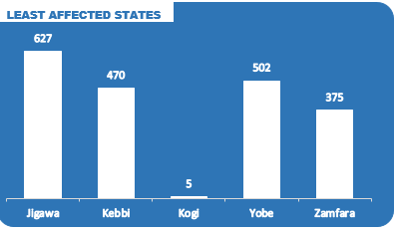

* + Kogi’s low reported case numbers could be due to **limited testing capacity, low public health surveillance, or possible resistance to COVID-19 containment measures**.
  + Despite reporting only 5 cases, the **40% death rate is highly unusual**, suggesting either significant underreporting of infections or inadequate healthcare response.
  + There were also concerns regarding **government transparency and political factors influencing data reporting**, which may have affected the accuracy of Kogi’s COVID-19 statistics.
  + The state’s relatively **lower population density and limited inter-state movement** could have contributed to fewer infections. However, **further investigation is needed** to clarify whether the reported data accurately reflects the true situation.
* Other states with low reported cases:
  + **Zamfara – 375 cases**
  + **Yobe – 502 cases**
  + **Kebbi – 470 cases**
  + **Jigawa – 627 cases**

These states may have experienced lower case numbers due to a combination of **lower population density, reduced testing rates, and limited movement**. However, to ensure comprehensive national coverage, more extensive testing and surveillance should be conducted in these regions.

**RECOMMENDATIONS**

1. **Investigate Data Accuracy:** Kogi’s low number of reported cases and extremely high death rate suggest significant discrepancies that require thorough verification.
2. **Monitor and Address the December Surge:** The spike in cases during December highlights the need for **seasonal public health interventions, travel restrictions, and increased awareness campaigns**.
3. **Improve Testing and Reporting in Least Affected States:** To ensure a complete understanding of COVID-19’s impact, **more extensive testing, case tracking, and reporting should be encouraged** in states with low reported cases.
4. **Strengthen Public Health Interventions in High-Risk Areas:** Lagos, FCT, Rivers, and other major hotspots should continue to implement **preventive measures, vaccination campaigns, and health facility improvements**.
5. **Increase Awareness Campaigns:** Public health education remains a crucial tool in **combating misinformation, promoting vaccination, and encouraging preventive behaviors such as mask-wearing and social distancing**.

**CONCLUSION**

The **COVID-19 pandemic in 2021 demonstrated both progress and challenges** in disease management across Nigeria. While the high recovery rate and overall low death rate are positive indicators, inconsistencies in state-reported data, the December surge, and the need for enhanced testing require urgent attention. By adopting **data-driven policies, improving healthcare access, and maintaining public health interventions**, Nigeria can better manage future outbreaks and reduce the long-term impact of COVID-19.

**DASHBOARD PRESENTATION**

